

Project File
on
[R Programming]
Subject Code: [26CAP-632]

Project Title: Football Player Analysis of Real Madrid Squad Using R

Submitted By:  Name: Ashutosh Dash  UID: 26MCD10089  Class: 26MCD-2  Section: A | Submitted To:  Name: Ravi Kumar  Designation: Assistant Professor  Ecode: E20675

Master of Computer Applications (MCA)
University Institute of Computing
Chandigarh University,
Gharuan, Mohali, Punjab, India-140413

BONAFIDE CERTIFICATE

Certified that this project report “Football Player Analysis of Real Madrid Squad Using R” is the bonafide work of “Ashutosh Dash, UID: 26MCD10089” who carried out the project work under my/our supervision. The content and findings presented herein are authentic and reflect the original work conducted during the course of this project.

SIGNATURE  Dr. [HOD NAME]  HEAD OF DEPARTMENT MCA | SIGNATURE  [SUPERVISOR NAME]  AP, UIC  SUPERVISOR

Submitted for the project viva-voce examination held on __ / __ / 2026

INTERNAL EXAMINER  Name : [Name]  EID : [ID] | EXTERNAL EXAMINER  Name : [Name]  EID : [ID]

ACKNOWLEDGEMENT
I would like to express my sincere gratitude to everyone who contributed to the successful completion of this mini project. Analysing football player data with R was a valuable learning experience, and I am grateful for the guidance and support I received along the way.
I extend my heartfelt thanks to [Faculty Name], Assistant Professor, MCA, University Institute of Computing, for the encouragement, guidance and willingness to clear my doubts, which were instrumental in completing this project.
I also thank all the faculty members of the department for their valuable suggestions, and my friends for their constant motivation and support.

Ashutosh Dash
UID: 26MCD10089

ABSTRACT
Football clubs, analysts and fans generate large amounts of player statistics every season, but raw numbers in tables are hard to read. It is difficult to see at a glance who scores most, who creates the most chances, how different positions contribute and how the squad is balanced in age. This project presents a data analysis of a Real Madrid first-team squad of 20 players using the R programming language.
The analysis is developed in RStudio with the dplyr and ggplot2 packages. Each player record contains position, age, matches, goals, assists and minutes played. Three derived measures are calculated: goal contributions (goals + assists), goals per 90 minutes and goal contributions per 90 minutes. dplyr is used to rank players and summarise statistics by position, and ggplot2 is used to build four plots: goals by player, goals versus assists, average goals by position and the age distribution of the squad. The results are saved as PNG images and as a CSV file. The project shows how a short and reproducible R script can turn raw football statistics into clear and useful insights.
TABLE OF CONTENTS

Acknowledgement and Abstract 3
CHAPTER 1: INTRODUCTION 5
1.1. Project Scope and Project Planning 5
1.2. Client Identification and Recognition of Need 5
1.3. Recognition and Knowledge of Relevant Contemporary Issues 5
1.4. Task Identification 5
1.5. Technologies Used 6
1.6. Timeline of the Project 6
CHAPTER 2: LITERATURE REVIEW / BACKGROUND STUDY 6
2.1. Existing Solutions 6
2.2. Review Summary 6
2.3. Problem Definition 6
2.4. Goals / Objectives 6
CHAPTER 3: DESIGN FLOW / PROCESS 7
3.1. Evaluation and Selection of Features 7
3.2. Design Constraints 7
3.3. Design Flow 7
3.4. Data Design 7
3.5. Implementation Plan / Methodology 8
CHAPTER 4: IMPLEMENTATION, RESULTS ANALYSIS AND VALIDATION 8
4.1. Environment Setup 8
4.2. Dataset Creation 8
4.3. Feature Engineering 9
4.4. Statistical Analysis 9
4.5. Data Visualisation 10
4.6. Exporting the Results 12
4.7. Results Analysis 12
4.8. Test Cases and Validation 13
CHAPTER 5: CONCLUSION AND FUTURE WORK 13
REFERENCES 14
APPENDIX: COMPLETE R SOURCE CODE 15
GITHUB REPOSITORY AND PROJECT SCREENSHOT 16

LIST OF FIGURES

Fig 3.1: Workflow of the Real Madrid player analysis 7
Fig 4.1: Real Madrid: Goals by Player 10
Fig 4.2: Goals vs Assists 11
Fig 4.3: Average Goals by Position 11
Fig 4.4: Age Distribution of Squad 12
Fig 4.5: RStudio output: environment, plot pane and console 12
CHAPTER 1.
INTRODUCTION
Modern football produces a large amount of data: every match adds goals, assists, minutes played and many other numbers to a player’s record. Looking at these numbers in a table makes it hard to answer simple questions. Who is the main goal scorer? Which players create the most chances? Do forwards really score much more than midfielders? How old is the squad? The Football Player Analysis project developed in this mini project answers such questions by analysing a Real Madrid first-team squad using the R programming language.
R is widely used in data science for data manipulation, statistics and visualisation. In this project, the dplyr package is used to transform and summarise the data, and the ggplot2 package is used to draw clear plots. The complete workflow is written as a single R script that creates the dataset, calculates new measures, ranks players, summarises positions, draws four plots and saves the results as image and CSV files.
1.1. Project Scope and Project Planning
The scope of the project covers the analysis of a squad of 20 players with the variables player name, position, age, matches, goals, assists and minutes played. Within scope are data preparation, calculation of derived measures, ranking of top performers, position-wise summaries, four visualisations and export of the results. Live data collection from websites or APIs, match-by-match data and predictive models are outside the scope of this mini project and are listed under future work.
Project planning involves the following phases:
- Requirement analysis: Deciding which questions the analysis must answer.
- Data preparation: Creating the player data frame with the required variables.
- Feature engineering: Calculating goal contributions, goals per 90 and contributions per 90.
- Analysis: Ranking players and summarising statistics by position with dplyr.
- Visualisation: Building four ggplot2 plots and saving them as PNG files.
- Testing and documentation: Verifying the outputs, saving the CSV file and preparing this report.
1.2. Client Identification and Recognition of Need
The primary clients of this analysis are football analysts and coaching staff, who need a quick summary of how players are performing. Fans, journalists and students of data science are indirect beneficiaries because clear plots and tables help them understand a squad without reading raw numbers. The need is for a simple, repeatable and well-documented analysis that can be re-run whenever the player data changes.
1.3. Recognition and Knowledge of Relevant Contemporary Issues
Data-driven decision making is now a standard part of professional sport. Clubs use statistics to evaluate players, plan squads and compare positions. A contemporary issue is that raw totals can mislead: a substitute who plays 700 minutes cannot be compared with a regular starter who plays 3,000 minutes using total goals alone. Per-90-minute measures solve this problem by scaling every player to the same playing time, and they are used in this project. Other important issues are data quality, reproducibility of analysis and the responsible use of statistics when judging players.
1.4. Task Identification
- Data: Create the players data frame with 20 players and seven variables.
- Derived measures: Add goal contributions, goals per 90 and contributions per 90 using mutate().
- Ranking: List the top 5 scorers and the top 5 players by goal contributions.
- Summary: Calculate the number of players, average age, average goals and average assists for each position.
- Visualisation: Create four plots with ggplot2 and save them as PNG files.
- Export: Save the full result table as real_madrid_analysis_result.csv.
1.5. Technologies Used
Layer | Technology | Purpose
Language | R 4.x | Data handling, statistics and plotting
IDE | RStudio | Writing and running the script, viewing plots
Data manipulation | dplyr package | mutate, arrange, select, group_by and summarise
Visualisation | ggplot2 package | Bar chart, scatter plot and histogram
Output | PNG and CSV files | Saved plots and the result table
Version control | Git and GitHub | Storing and sharing the project

1.6. Timeline of the Project
Phase | Activity | Duration
Phase 1 | Planning, requirement analysis and data design | Week 1
Phase 2 | Data frame creation and derived measures | Week 1 – 2
Phase 3 | Ranking, summaries and ggplot2 visualisation | Week 2 – 3
Phase 4 | Testing, GitHub upload and report writing | Week 3
CHAPTER 2.
LITERATURE REVIEW / BACKGROUND STUDY
2.1. Existing Solutions
Football statistics are currently analysed using a range of approaches, each with its own strengths and limitations:
- Manual tables and spreadsheets: Simple and widely used, but ranking, grouping and charting by hand is slow, and mistakes are common when the data changes.
- Commercial analytics platforms: Professional data providers offer detailed event data and ready-made dashboards, but their subscription costs are high and they are not available for learning projects.
- Public statistics websites: Websites publish player statistics for free, but they show fixed tables and do not allow custom measures or reproducible analysis.
- Programming-based analysis: Languages such as R and Python allow custom measures, repeatable scripts and high-quality plots. This is the approach followed in this project.
2.2. Review Summary
The review shows that useful player analysis needs only a few core steps: clean data, meaningful derived measures, ranking and grouping, and clear visualisation. The dplyr package provides a readable grammar for data manipulation, and ggplot2 provides a layered grammar of graphics for building plots step by step. Normalising statistics per 90 minutes is a common practice that allows fair comparison between regular starters and substitutes. These ideas are combined in this project in one short R script.
2.3. Problem Definition
To design and develop an R-based analysis of the Real Madrid squad that calculates goal contributions and per-90 measures, ranks the top performers, summarises statistics by position, presents the results through clear visualisations, and exports them as PNG and CSV files so that the analysis can be repeated and shared.
2.4. Goals / Objectives
- Data preparation: Build a clean data frame of 20 players with seven variables.
- Derived measures: Calculate goal contributions, goals per 90 and contributions per 90.
- Ranking: Identify the top 5 scorers and the top 5 players by goal contributions.
- Position analysis: Compare average age, goals and assists across GK, DEF, MID and FWD.
- Visualisation: Produce four clear and labelled plots using ggplot2.
- Reproducibility: Save the plots and the result table so that the work can be reused.
CHAPTER 3.
DESIGN FLOW / PROCESS
3.1. Evaluation and Selection of Features
Features were selected on the basis of the questions a football analyst asks most often and what can be built reliably within the project time: a ranking of top scorers, a ranking by goal contributions (goals plus assists), a summary by playing position, a goals-versus-assists comparison and a view of the age structure of the squad. Per-90 measures were included so that players with different playing time can be compared fairly. Live data collection and match-level analysis were deferred.
3.2. Design Constraints
The project was designed within the following constraints: only the R language with the dplyr and ggplot2 packages; a squad-level dataset of 20 players created inside the script, so that the project runs without any external file; static plots saved as PNG images; a single script that can be run from top to bottom in RStudio; and a limited project duration. The dataset used in this project is a sample prepared for the analysis, so the findings describe this dataset and are not official statistics.
3.3. Design Flow
The analysis follows a simple pipeline. The script first loads the packages and creates the players data frame. The derived measures are then added using mutate(). The data is ranked and grouped with dplyr to produce the summary tables, and the results are passed to ggplot2 to draw the plots. Finally, the plots are saved as PNG files and the full table is written to a CSV file.
Create data frame | → | Add derived measures | → | Rank and summarise (dplyr) | → | Plot (ggplot2) | → | Save PNG and CSV
Fig 3.1: Workflow of the Real Madrid player analysis
3.4. Data Design
The dataset is stored in a data frame named players. Seven variables are entered directly, and three are derived by the script.
Variable | Type | Description
Player | Character | Name of the player
Position | Character | Playing position: GK, DEF, MID or FWD
Age | Numeric | Age of the player in years
Matches | Numeric | Number of matches played
Goals | Numeric | Number of goals scored
Assists | Numeric | Number of assists made
Minutes | Numeric | Total minutes played
Goal_Contributions | Derived | Goals + Assists
Goals_per_90 | Derived | Goals / Minutes × 90, rounded to 2 decimals
Contrib_per_90 | Derived | Goal_Contributions / Minutes × 90, rounded to 2 decimals

3.5. Implementation Plan / Methodology
The script is implemented step by step from top to bottom: packages and data first, then derived measures, then rankings and summaries, then the four plots, and finally the export. Each step is run and its output checked in the RStudio console before moving to the next. Results are printed to the console and drawn in the Plots pane, then saved to the working directory.
CHAPTER 4.
IMPLEMENTATION, RESULTS ANALYSIS AND VALIDATION
This chapter presents the implementation step by step. Each step shows the R code used and the result it produces. The complete script is given in the Appendix.
4.1. Environment Setup
The script starts by loading ggplot2 for plotting and dplyr for data manipulation. If the packages are not installed, they can be installed once using install.packages(c("ggplot2", "dplyr")).
library(ggplot2)
library(dplyr)

4.2. Dataset Creation
The players data frame is created with seven vectors of equal length (one value per player). The first five rows of each vector belong to the goalkeeper and defenders, followed by midfielders and forwards.
players <- data.frame(
Player = c("Courtois", "Carvajal", "Militao", "Rudiger", "Mendy",
"Tchouameni", "Valverde", "Camavinga", "Bellingham", "Guler",
"Modric", "Vinicius Jr", "Rodrygo", "Mbappe", "Brahim Diaz",
"Endrick", "Asencio", "Fran Garcia", "Ceballos", "Lucas Vazquez"),
Position = c("GK", "DEF", "DEF", "DEF", "DEF",
"MID", "MID", "MID", "MID", "MID",
"MID", "FWD", "FWD", "FWD", "FWD",
"FWD", "DEF", "DEF", "MID", "DEF"),
Age = c(34, 34, 28, 33, 30, 26, 27, 23, 23, 21,
40, 25, 25, 27, 26, 20, 20, 26, 30, 35),
Matches = c(30, 28, 25, 29, 22, 32, 36, 30, 33, 28,
24, 35, 31, 37, 29, 18, 20, 24, 15, 22),
Goals = c(0, 2, 1, 3, 0, 2, 6, 1, 12, 5,
2, 18, 9, 31, 7, 6, 1, 1, 1, 2),
Assists = c(0, 5, 0, 1, 2, 2, 8, 3, 9, 7,
4, 12, 6, 6, 5, 2, 0, 3, 2, 4),
Minutes = c(2700, 2300, 2100, 2500, 1700, 2600, 3000, 2400, 2800, 2000,
1200, 3000, 2300, 3200, 1900, 700, 1500, 1800, 800, 1400)
)

The complete dataset including the derived columns is shown in Table 4.1.
Player | Pos | Age | Matches | Goals | Assists | Minutes | G + A | Goals /90 | G+A /90
Courtois | GK | 34 | 30 | 0 | 0 | 2700 | 0 | 0.00 | 0.00
Carvajal | DEF | 34 | 28 | 2 | 5 | 2300 | 7 | 0.08 | 0.27
Militao | DEF | 28 | 25 | 1 | 0 | 2100 | 1 | 0.04 | 0.04
Rudiger | DEF | 33 | 29 | 3 | 1 | 2500 | 4 | 0.11 | 0.14
Mendy | DEF | 30 | 22 | 0 | 2 | 1700 | 2 | 0.00 | 0.11
Tchouameni | MID | 26 | 32 | 2 | 2 | 2600 | 4 | 0.07 | 0.14
Valverde | MID | 27 | 36 | 6 | 8 | 3000 | 14 | 0.18 | 0.42
Camavinga | MID | 23 | 30 | 1 | 3 | 2400 | 4 | 0.04 | 0.15
Bellingham | MID | 23 | 33 | 12 | 9 | 2800 | 21 | 0.39 | 0.68
Guler | MID | 21 | 28 | 5 | 7 | 2000 | 12 | 0.22 | 0.54
Modric | MID | 40 | 24 | 2 | 4 | 1200 | 6 | 0.15 | 0.45
Vinicius Jr | FWD | 25 | 35 | 18 | 12 | 3000 | 30 | 0.54 | 0.90
Rodrygo | FWD | 25 | 31 | 9 | 6 | 2300 | 15 | 0.35 | 0.59
Mbappe | FWD | 27 | 37 | 31 | 6 | 3200 | 37 | 0.87 | 1.04
Brahim Diaz | FWD | 26 | 29 | 7 | 5 | 1900 | 12 | 0.33 | 0.57
Endrick | FWD | 20 | 18 | 6 | 2 | 700 | 8 | 0.77 | 1.03
Asencio | DEF | 20 | 20 | 1 | 0 | 1500 | 1 | 0.06 | 0.06
Fran Garcia | DEF | 26 | 24 | 1 | 3 | 1800 | 4 | 0.05 | 0.20
Ceballos | MID | 30 | 15 | 1 | 2 | 800 | 3 | 0.11 | 0.34
Lucas Vazquez | DEF | 35 | 22 | 2 | 4 | 1400 | 6 | 0.13 | 0.39
Table 4.1: Player dataset with derived measures
4.3. Feature Engineering
Raw totals favour players who play more minutes, so three new columns are added using mutate(). Goal_Contributions adds goals and assists. Goals_per_90 and Contrib_per_90 divide by the minutes played and multiply by 90, so every player is measured over the same playing time.
players <- players %>%
mutate(
Goal_Contributions = Goals + Assists,
Goals_per_90 = round(Goals / Minutes * 90, 2),
Contrib_per_90 = round(Goal_Contributions / Minutes * 90, 2)
)

4.4. Statistical Analysis
dplyr functions are chained with the pipe operator (%>%). arrange(desc()) sorts the players, select() keeps the required columns and head(5) shows the first five rows. group_by() and summarise() calculate the position-wise averages.
cat("Top 5 scorers:\n")
print(players %>% arrange(desc(Goals)) %>% select(Player, Position, Goals) %>% head(5))

cat("\nTop 5 by goal contributions (goals + assists):\n")
print(players %>% arrange(desc(Goal_Contributions)) %>%
select(Player, Goals, Assists, Goal_Contributions) %>% head(5))

cat("\nAverage stats by position:\n")
position_summary <- players %>%
group_by(Position) %>%
summarise(Players = n(),
Avg_Age = round(mean(Age), 1),
Avg_Goals = round(mean(Goals), 1),
Avg_Assists = round(mean(Assists), 1))
print(position_summary)

Top 5 scorers
Player | Position | Goals
Mbappe | FWD | 31
Vinicius Jr | FWD | 18
Bellingham | MID | 12
Rodrygo | FWD | 9
Brahim Diaz | FWD | 7
Table 4.2: Top 5 scorers
Top 5 by goal contributions (goals + assists)
Player | Goals | Assists | Goal_Contributions
Mbappe | 31 | 6 | 37
Vinicius Jr | 18 | 12 | 30
Bellingham | 12 | 9 | 21
Rodrygo | 9 | 6 | 15
Valverde | 6 | 8 | 14
Table 4.3: Top 5 players by goal contributions
Average statistics by position
Position | Players | Avg_Age | Avg_Goals | Avg_Assists
DEF | 7 | 29.4 | 1.4 | 2.1
FWD | 5 | 24.6 | 14.2 | 6.2
GK | 1 | 34.0 | 0.0 | 0.0
MID | 7 | 27.1 | 4.1 | 5.0
Table 4.4: Position summary
4.5. Data Visualisation
Four plots are created with ggplot2. Each plot is built in layers: the data and aesthetics with ggplot(), the shape with a geom function, labels with labs() and the clean look with theme_minimal(). print() displays the plot in the Plots pane and ggsave() writes it to a PNG file.
(a) Goals by player
A horizontal bar chart ranks the players by goals. Players with zero goals are removed with filter(Goals > 0), reorder() sorts the bars and coord_flip() makes the names easy to read. The fill colour shows the position.
p1 <- ggplot(players %>% filter(Goals > 0),
aes(x = reorder(Player, Goals), y = Goals, fill = Position)) +
geom_col() +
coord_flip() +
labs(title = "Real Madrid: Goals by Player", x = "Player", y = "Goals") +
theme_minimal()
print(p1)
ggsave("rm_goals_by_player.png", p1, width = 8, height = 6)

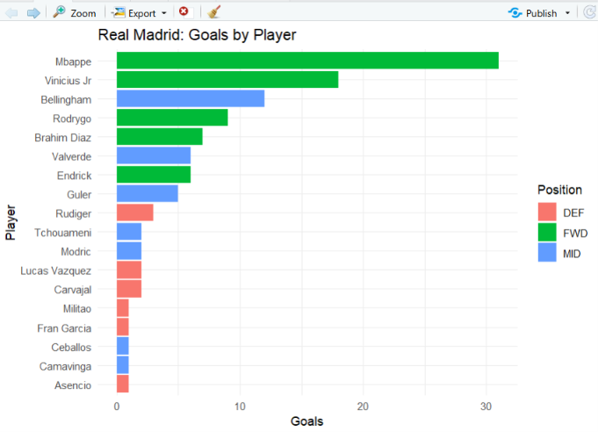
Fig 4.1: Real Madrid: Goals by Player
Mbappe is clearly the top scorer with 31 goals, followed by Vinicius Jr (18) and Bellingham (12). The top five bars are mostly forwards, and the defenders (red) are all at the bottom with three goals or fewer.
(b) Goals versus assists
A scatter plot places each player by goals (x-axis) and assists (y-axis). geom_text() writes the player names next to the points, and check_overlap = TRUE hides labels that would overlap.
p2 <- ggplot(players, aes(x = Goals, y = Assists, color = Position, label = Player)) +
geom_point(size = 3) +
geom_text(vjust = -0.8, size = 3, check_overlap = TRUE) +
labs(title = "Goals vs Assists", x = "Goals", y = "Assists") +
theme_minimal()
print(p2)
ggsave("rm_goals_vs_assists.png", p2, width = 8, height = 6)

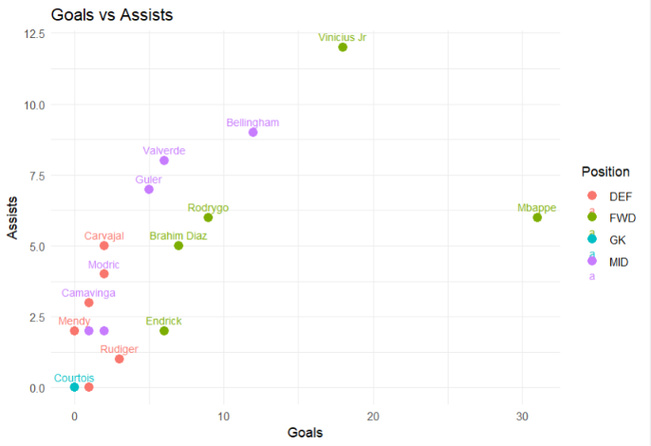
Fig 4.2: Goals vs Assists
Mbappe sits far to the right because of his goals, while Vinicius Jr is highest on the assists axis with 12. Bellingham, Valverde and Guler combine a good number of goals with many assists, which shows their creative role in midfield. The goalkeeper is at the origin.
(c) Average goals by position
A bar chart compares the average goals of the four positions using the position_summary table created in Section 4.4.
p3 <- ggplot(position_summary, aes(x = Position, y = Avg_Goals, fill = Position)) +
geom_col() +
labs(title = "Average Goals by Position", x = "Position", y = "Average Goals") +
theme_minimal()
print(p3)
ggsave("rm_avg_goals_by_position.png", p3, width = 6, height = 5)

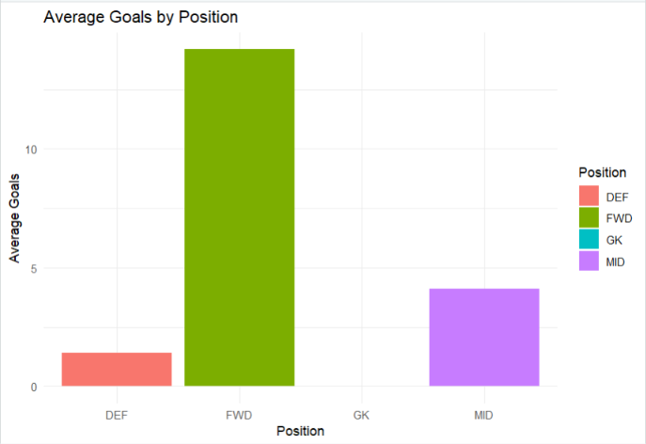
Fig 4.3: Average Goals by Position
Forwards average 14.2 goals, which is much higher than midfielders (4.1) and defenders (1.4). The goalkeeper has no bar because the average is zero. This confirms the expected pattern that scoring is concentrated in the attacking positions.
(d) Age distribution of the squad
A histogram with a bin width of 2 years shows how many players fall into each age group.
p4 <- ggplot(players, aes(x = Age)) +
geom_histogram(binwidth = 2, fill = "steelblue", color = "white") +
labs(title = "Age Distribution of Squad", x = "Age", y = "Number of Players") +
theme_minimal()
print(p4)
ggsave("rm_age_distribution.png", p4, width = 6, height = 5)

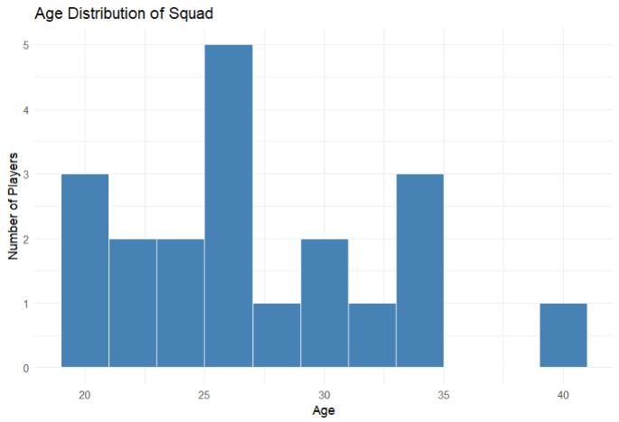
Fig 4.4: Age Distribution of Squad
The tallest bar is at 25 to 27 years with five players, so the squad is built around players in their mid-twenties. There is also a group of 20 to 21-year-olds and a group of players around 33 to 35, with the oldest player at 40. The mean age of the squad is 27.6 years.
4.6. Exporting the Results
The full table, including the derived columns, is written to a CSV file with write.csv(), and a completion message with the working folder is printed with cat() and getwd(). The four plots were already saved by ggsave().
write.csv(players, "real_madrid_analysis_result.csv", row.names = FALSE)
cat("\nAnalysis complete. Files saved in:", getwd(), "\n")

Figure 4.5 shows the RStudio window after running the script: the script in the editor, the players and position_summary objects in the Environment pane, a plot in the Plots pane and the completion message in the Console.
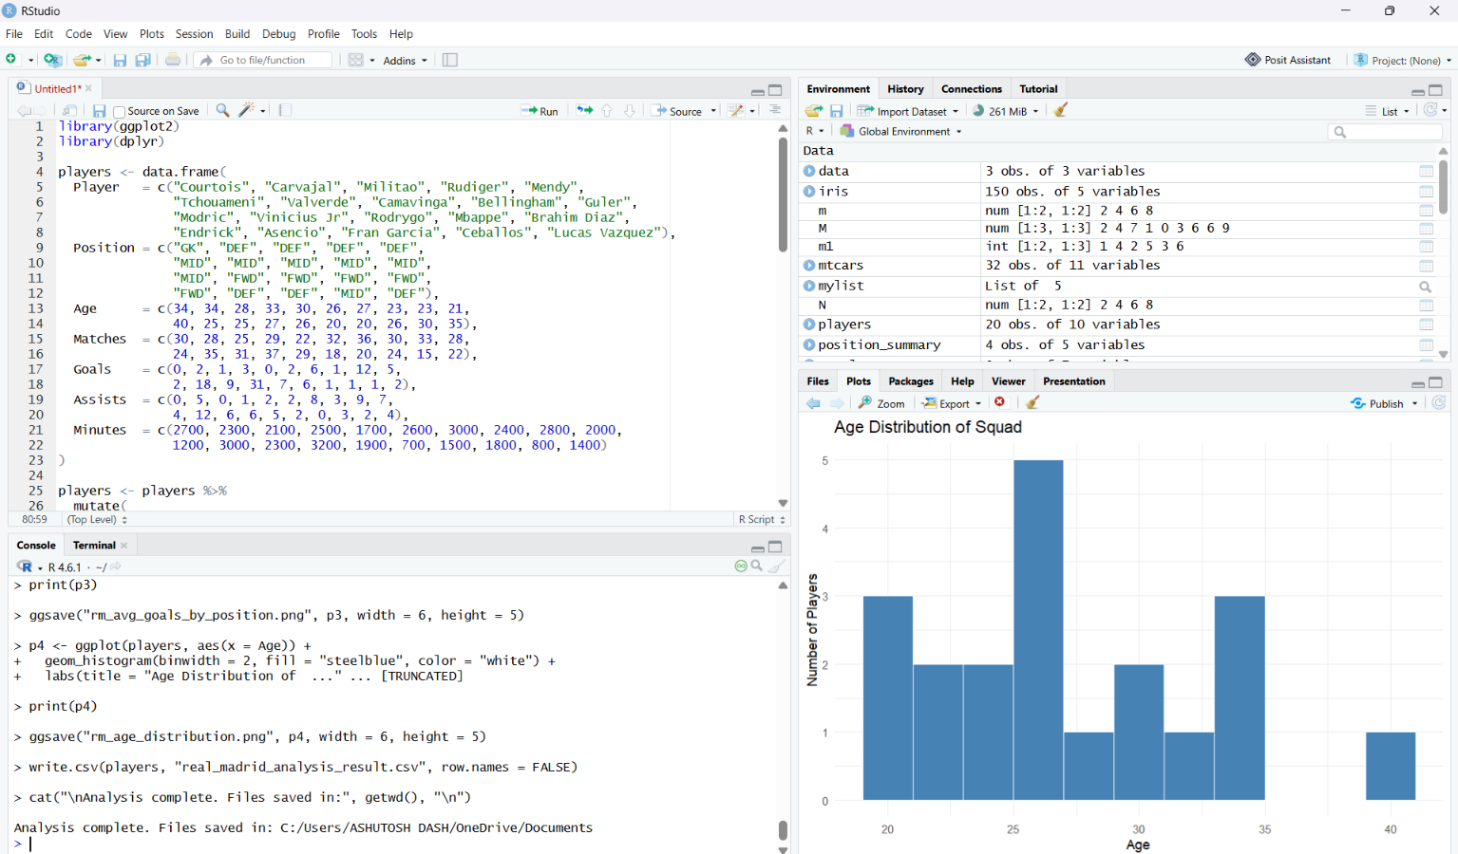
Fig 4.5: RStudio output: environment, plot pane and console
4.7. Results Analysis
- Top scorer: Mbappe leads the squad with 31 goals and 37 goal contributions, ahead of Vinicius Jr (18 goals, 30 contributions) and Bellingham (12 goals, 21 contributions).
- Best creator: Vinicius Jr has the most assists (12), followed by Bellingham (9) and Valverde (8).
- Per-90 view: Mbappe also has the best rate of 0.87 goals per 90 minutes. Endrick is second with 0.77 goals per 90, although he played only 700 minutes, which shows why per-90 measures are needed for fair comparison.
- Positions: Forwards average 14.2 goals and 6.2 assists, midfielders 4.1 goals and 5.0 assists, and defenders 1.4 goals and 2.1 assists. Midfielders are the main source of assists after the forwards.
- Squad totals: The 20 players have 110 goals and 81 assists in total, and the average age is 27.6 years.
- Limitation: The dataset is a sample of one season for 20 players, so the findings describe this dataset only and should be repeated with official data before drawing real-world conclusions.
4.8. Test Cases and Validation
The following test cases were prepared from the implemented script to validate its main steps.
# | Test case | Input / action | Expected result
1 | Package loading | Run library(ggplot2) and library(dplyr) | Both packages load without errors
2 | Dataset creation | Run the data.frame() statement | players has 20 observations of 7 variables
3 | Derived columns | Run the mutate() statement | Three new columns; players has 10 variables
4 | Top scorers | arrange(desc(Goals)) and head(5) | Mbappe 31, Vinicius Jr 18, Bellingham 12, Rodrygo 9, Brahim Diaz 7
5 | Position summary | group_by(Position) and summarise() | position_summary has 4 rows: DEF, FWD, GK, MID
6 | Plots | Run print(p1) to print(p4) | Four plots appear in the Plots pane
7 | File export | Run ggsave() and write.csv() | Four PNG files and one CSV file are saved in the working folder
8 | Completion message | Run the last cat() statement | “Analysis complete. Files saved in:” with the folder path is printed
CHAPTER 5.
CONCLUSION AND FUTURE WORK
5.1. Conclusion
The Football Player Analysis project meets its objectives. Using R with dplyr and ggplot2, the squad data was prepared, three derived measures were calculated, the top performers were ranked, positions were compared and four clear plots were produced and saved. The analysis showed that forwards carry the goal-scoring load, that midfielders contribute many assists, and that per-90 measures give a fairer view of players with fewer minutes. The whole workflow is a short, readable script that can be re-run in seconds, which makes the analysis reproducible.
5.2. Future Work
- Real data: Replace the sample values with official season statistics from public sources or a data API.
- More measures: Add expected goals (xG), passes, tackles and defensive statistics to evaluate defenders and goalkeepers fairly.
- Interactive dashboard: Build a Shiny application where the user can pick a player, position or season.
- Season comparison: Analyse several seasons to study the progress of players and the changes in the squad.
- Club comparison: Compare Real Madrid with other clubs using the same script.
- Prediction: Use regression or other machine learning models to predict goals from minutes, age and position.

REFERENCES

1. R Core Team, “R: A Language and Environment for Statistical Computing,” R Foundation for Statistical Computing, Vienna, Austria.
2. H. Wickham, ggplot2: Elegant Graphics for Data Analysis, Springer, 2016.
3. H. Wickham, R. François, L. Henry and K. Müller, “dplyr: A Grammar of Data Manipulation,” R package documentation.
4. H. Wickham and G. Grolemund, R for Data Science, O’Reilly Media, 2017.
5. Posit Software, PBC, “RStudio IDE User Guide,” Posit Documentation.
6. S. Chacon and B. Straub, Pro Git, 2nd ed., Apress, 2014.
7. Project source code: https://github.com/ashutoshdash8/real-madrid-player-analysis-r.git

APPENDIX
COMPLETE R SOURCE CODE
library(ggplot2)
library(dplyr)

players <- data.frame(
Player = c("Courtois", "Carvajal", "Militao", "Rudiger", "Mendy",
"Tchouameni", "Valverde", "Camavinga", "Bellingham", "Guler",
"Modric", "Vinicius Jr", "Rodrygo", "Mbappe", "Brahim Diaz",
"Endrick", "Asencio", "Fran Garcia", "Ceballos", "Lucas Vazquez"),
Position = c("GK", "DEF", "DEF", "DEF", "DEF",
"MID", "MID", "MID", "MID", "MID",
"MID", "FWD", "FWD", "FWD", "FWD",
"FWD", "DEF", "DEF", "MID", "DEF"),
Age = c(34, 34, 28, 33, 30, 26, 27, 23, 23, 21,
40, 25, 25, 27, 26, 20, 20, 26, 30, 35),
Matches = c(30, 28, 25, 29, 22, 32, 36, 30, 33, 28,
24, 35, 31, 37, 29, 18, 20, 24, 15, 22),
Goals = c(0, 2, 1, 3, 0, 2, 6, 1, 12, 5,
2, 18, 9, 31, 7, 6, 1, 1, 1, 2),
Assists = c(0, 5, 0, 1, 2, 2, 8, 3, 9, 7,
4, 12, 6, 6, 5, 2, 0, 3, 2, 4),
Minutes = c(2700, 2300, 2100, 2500, 1700, 2600, 3000, 2400, 2800, 2000,
1200, 3000, 2300, 3200, 1900, 700, 1500, 1800, 800, 1400)
)

players <- players %>%
mutate(
Goal_Contributions = Goals + Assists,
Goals_per_90 = round(Goals / Minutes * 90, 2),
Contrib_per_90 = round(Goal_Contributions / Minutes * 90, 2)
)

cat("Top 5 scorers:\n")
print(players %>% arrange(desc(Goals)) %>% select(Player, Position, Goals) %>% head(5))

cat("\nTop 5 by goal contributions (goals + assists):\n")
print(players %>% arrange(desc(Goal_Contributions)) %>%
select(Player, Goals, Assists, Goal_Contributions) %>% head(5))

cat("\nAverage stats by position:\n")
position_summary <- players %>%
group_by(Position) %>%
summarise(Players = n(),
Avg_Age = round(mean(Age), 1),
Avg_Goals = round(mean(Goals), 1),
Avg_Assists = round(mean(Assists), 1))
print(position_summary)

p1 <- ggplot(players %>% filter(Goals > 0),
aes(x = reorder(Player, Goals), y = Goals, fill = Position)) +
geom_col() +
coord_flip() +
labs(title = "Real Madrid: Goals by Player", x = "Player", y = "Goals") +
theme_minimal()
print(p1)
ggsave("rm_goals_by_player.png", p1, width = 8, height = 6)

p2 <- ggplot(players, aes(x = Goals, y = Assists, color = Position, label = Player)) +
geom_point(size = 3) +
geom_text(vjust = -0.8, size = 3, check_overlap = TRUE) +
labs(title = "Goals vs Assists", x = "Goals", y = "Assists") +
theme_minimal()
print(p2)
ggsave("rm_goals_vs_assists.png", p2, width = 8, height = 6)

p3 <- ggplot(position_summary, aes(x = Position, y = Avg_Goals, fill = Position)) +
geom_col() +
labs(title = "Average Goals by Position", x = "Position", y = "Average Goals") +
theme_minimal()
print(p3)
ggsave("rm_avg_goals_by_position.png", p3, width = 6, height = 5)

p4 <- ggplot(players, aes(x = Age)) +
geom_histogram(binwidth = 2, fill = "steelblue", color = "white") +
labs(title = "Age Distribution of Squad", x = "Age", y = "Number of Players") +
theme_minimal()
print(p4)
ggsave("rm_age_distribution.png", p4, width = 6, height = 5)

write.csv(players, "real_madrid_analysis_result.csv", row.names = FALSE)
cat("\nAnalysis complete. Files saved in:", getwd(), "\n")
GITHUB REPOSITORY:
GitHub Repository Link
GitHub: https://github.com/ashutoshdash8/real-madrid-player-analysis-r.git
